1. A close-up of a computer screen

   Description automatically generated Python script execution results
2. A screenshot of a computer

   Description automatically generatedSecurity Group for VM1
3. **A screenshot of a computer

   Description automatically generated** Security Group for VM3
4. A screenshot of a computer

   Description automatically generatedSecurity Group for VM3
5. A screenshot of a computer

   Description automatically generatedVM1
6. A computer screen shot of a black screen

   Description automatically generatedConnectivity to VM1 from my laptop with ping
7. A screenshot of a computer screen

   Description automatically generatedConnectivity to VM1 from my laptop with traceroute
8. A screenshot of a computer program

   Description automatically generated Connectivity to VM1 from my laptop with SSH
9. A screenshot of a computer

   Description automatically generatedVM2
10. 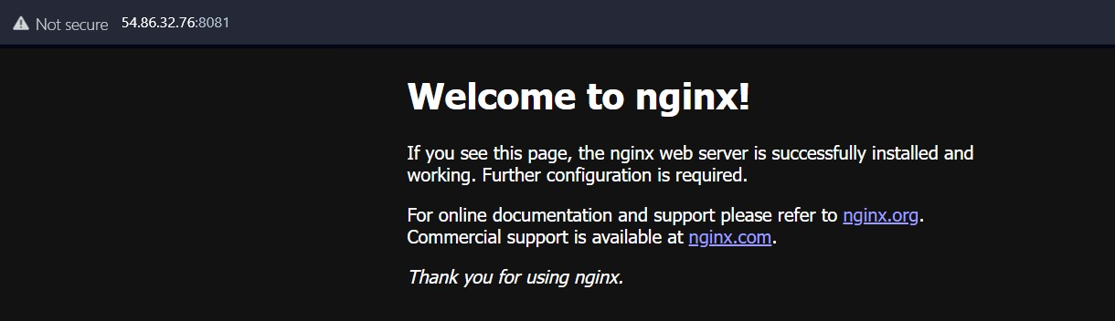Connectivity the laptop to webservers on VM2 ports 8081 and 8082  
      
    A screenshot of a computer

    Description automatically generated
11. A screenshot of a computer

    Description automatically generatedVM3
12. A screenshot of a computer

    Description automatically generatedConnectivity the laptop to webservers on VM3 ports 8083 and 8084
13. 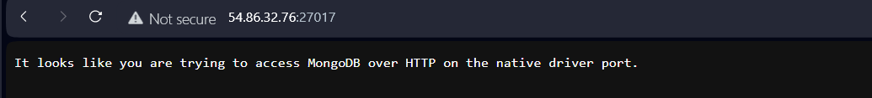A screenshot of a computer

    Description automatically generatedHTTP traffic analysis with Wireshark  
      
    A screenshot of a computer screen

    Description automatically generated  
      
    Question and Answers

1. **How does your PC start the conversation?** What are the source and destination IPv4 addresses? What are the source and destination TCP ports? What are the TCP messages involved?

**Ans –** My PC starts the conversation with a TCP Handshake: SYN, SYN-ACK and ACK.  
  
**Source IPv4 Addresses:** 192.168.2.48  
**Destination IPv4 Addresses:** 54.86.32.76  
**Source TCP Ports:** 59403  
**Destination TCP Ports:** 27017  
  
In the first two conversations, **SYN** message is sent and in third conversation **SYN-ACK** is sent and in the fourth only **ACK** is sent to the destination.

1. **When does the HTTP protocol appear in the conversation?** What is the HTTP message sent by the PC and what is the reply? Is the conversation clear text?

**Ans –** The HTTP protocol appears at the fifth conversation and the PC sends **GET** message and receives **OK** message from the source. The received message is a clear text and the text says, “It looks like you are trying to access MongoDB over HTTP on the native driver port.”

1. **How does the conversation end?** What are the messages exchanged to close the session?

**Ans –** The conversation ends with the **FIN-ACK, RST-ACK,** and **RST** message.